
Shamsi School
Shamsi Society Campus (Boys’ Shift)
Final Examination (2024-25)
Class: VI
Subject: Mathematics

Name: __________________Sec: ____Roll #: _____ Invigilator’s Sign: ___ T.Marks: 100

OBJECTIVE Max. Marks: 20

Q1) Fill in the blanks. /06
- The ________________ is the distance around a figure.
- A set of all integers is an __________________ set.
- The symbol ϕ represents ________________ set.
- The number of elements in a set is called its ____________________.
- The formula for calculating the area of a rectangle is ______________
- The perimeter of a rectangle is calculated by the formula _______________

Q2) Write one examples of each of the given sets. /02

SETS | EXAMPLES
- Finite Set
- Empty Set
Q3) Find the square of the following numbers. /03
- 25 = _______________________________
- 19 = _______________________________
- 21 = _______________________________
Q4) Select the correct option. /03
- Which of these is not a part of a bar graph?
- Title (b) Y – axis (c) Sector
- How many degrees are there in a pie chart?
- 60 ⁰ (b) 90 ⁰ (c) 360 ⁰
- On the number line which is greater -15 or -3?
- -3 (b) -15 (c) They are equal
- The value of 5 × ( - 3 ) – ( - 3 ) is
- 18 (b) – 12 (c) – 18
- If 100% = Rs. 120, then Rs 84 is
- 120% (b) 70 % (c) 20 %
- If 75 % of pupils in a class of 40 passed in a science test, how many of them failed?
- 10 (b) 25 (c) 30

Q5) State whether the following are true or false. /03
- A right triangle can also be an isosceles triangle _____________.
- A scalene triangle is always an acute triangle _______________.
- An isosceles triangle can also be an obtuse-angles triangle ____________.
- The exterior angles of an equilateral triangle are not all equal ___________.
- A set of all the children in a school is a finite set ____________.
- P = { 1, 2, 3, …….., 10 } is written as P = { 1, 2, 3, 4, 5, 6, 7, 8, 9, 10 } in a set – builder form ____________.
Q6) Mark each statement in column A with its equivalent in column B. /03

COLUMN ‘A’ COLUMN ‘B’
- A number divided by 6 decreased (a) 2x + 1
by 5
- Twice a number increased by 1 (b) $\frac{x}{6}$ - 5
- 8 divided by two-third of a (c) 7x + 2
number
- Seven times a number increased (d) 6 - $\frac{3}{4}$ x
by 2
- Three – fourths of a number subtract (e) 8 ÷ $\frac{2}{3}$ x
from 6
- The sum of P and q (f) P + q


Shamsi School
Shamsi Society Campus (Boys’ Shift)
Final Examination (2024-25)
Subject: Mathematics
SUBJECTIVE Max. Marks:80
ARITHMETIC SECTION /36
Note: Attempt any 6 questions. All questions carry equal marks.
Q1) Simplify:
- 3 $\frac{2}{3}$ × $\frac{3}{11}$ + [ 2 $\frac{3}{4}$ ÷ 1 $\frac{1}{4}$ × ( - 1 $\frac{2}{3}$ ) ] + (- $\frac{1}{3}$ )
- 14 – [ 16 – { 17 – ( 18 – 6 – 3 ) } ]
Q2) Find the LCM of the following numbers by prime factorization method.
- 28 , 35 , 56 , 84
- (ii) 35 , 49 , 91

Q3) Calculate the LCM of the following numbers by the method of division.
- 16, 24, 30, 40, 48
- (ii) 14 , 21 , 56

Q4) Convert the following into percentage:
- $\frac{3}{50}$ (iii) 0 . 35
- 4 . 2
Q5) (a) Adila saves 16 % of her monthly salary. If she gets Rs21,000 per month, how much does she save every month?

(b) What percent of 240 is 30?

Q6) Express the first quantity as a percentage of the second quantity.
- 55 cm , 5 m
- 36 min, 6 hrs
Q7) Mr Saleem covered 36 % of a total journey of 150 km while Mr Sabir covered 30% of a total journey of 200 km. Who covered more distance?
Q8) The students of Class V and Class VI are asked about their favorite subject. Information is given in the table below:
Subject | Class V | Class VI
English | 4 | 7
Urdu | 5 | 5
Mathematics | 9 | 6
Science | 7 | 12

- What percentage of students of Class V like Mathematics?
- What percentage of students of Class VI like Mathematics?
- What percentage of students of Class V like Science?
- What percentage of students of Class VI like Science?
- Which subject is the favorite among Class V and Class VI students?

ALGEBRA SECTION /20
Note: Attempt all questions. All questions carry equal marks.

Q9) Simplify:
- 3 { a – 2 ( b – $\overline{a-b}$ ) }
- 5x – ( 3x + ( 4x – 2x ) }

Q9) By introducing parentheses evaluate the following.
- $\frac{5}{2x}$ + $\frac{y}{2x}$
- xy + zx + ax
- 24 – 8$y^{2}$+ $z^{2}$
- $x^{2}y$ + $x^{2}y^{2}$ + $x^{2}y^{3}$
- 16 – 2 $x^{2}$ – 2 $y^{2}$
Q10) (a) Twice a number added to half of itself equals 20. Find the number.
(b) Thrice a number decreased by 5 exceeds twice the number by a unit. Find the number.

Q11) Rehan buys a books and a pen and pays Rs 50 for both. The book costs Rs 8 more than twice the cost of the pen. Find the cost of the book.
GEOMETRY SECTION /24
Note: Attempt any 4 questions. All questions carry equal marks.

Q12) Find the perimeter of each of the following:
- A square of side 8cm
- A triangle of side 3cm, 4cm and 5cm
- A rectangle of sides 6 cm and 4cm
Q13) Find the area of each of the following rectangular fields whose dimensions are given.
- Length = 32 m , breadth = 24 m
- Length = 4.5 m , breadth = 2m 25 cm
- Length = 32 m , breadth = 24 m
Q14) Find the volume of each of the following cuboids.
- Length = 4 m , breadth = 2.5 m , height = 1.5 m
- Length = 12 cm , breadth = 10 cm , height = 8cm
- Length = 2 m 50 cm , breadth = 1 m , height = 75 cm
Q15) A tank is 5m long, 3m wide and 1.5m high. How many cubic meters of water can it hold?
Q16) Find the volume of each of the cubes whose edges are given below:
- 60 cm (b) 2 $\frac{2}{3}$ m (c) 60 cm
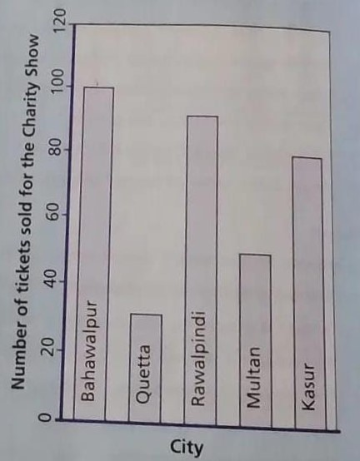Q17) Read the bar graph and answer the following questions:
- What is the general information given by the graph?
- How many tickets of the charity show was sold by the agents in total?
- In which city was the maximum number of tickets sold
- In which city was the minimum number of tickets old?
- The number of tickets sold in Bhagalpur is twice that of tickets sold in Multan. Is this true or false?

